**Practical – 3**

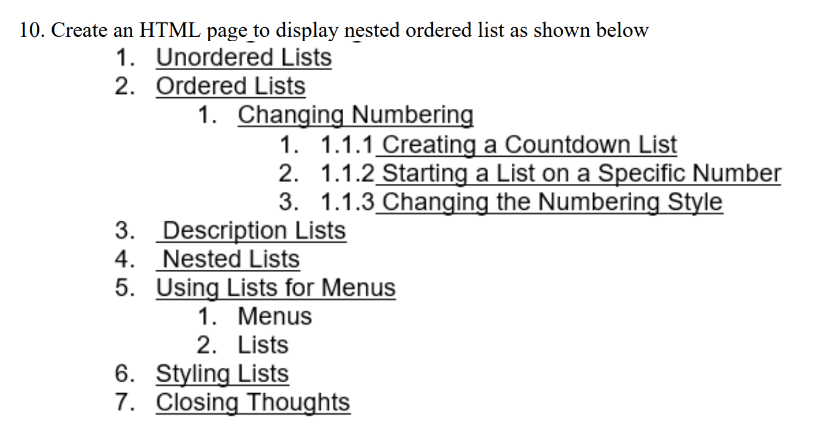

**HTML Code**

<!DOCTYPE html>

<html lang="en">

<head>

<meta charset="UTF-8">

<meta name="viewport" content="width=device-width, initial-scale=1.0">

<title>Rowspan & Colspan </title>

</head>

<body>

<ol type="1">

<li><u>Unordered Lists</u></li>

<li><u>Ordered Lists</u>

<ol type="1">

<li><u>Changing Numbering</u>

<ol type="1">

<li>1.1.1 <u>Creating a Countdown List</u></li>

<li>1.1.2 <u>Starting a List on a Specific Number</u></li>

<li>1.1.3 <u>Changing the Numbering Style</u></li>

</ol>

</li>

</ol>

</li>

<li><u>Description Lists</u></li>

<li><u>Nested Lists</u></li>

<li>

Using Lists for Menus

<ol type="1">

<li>Menus</li>

<li>Lists</li>

</ol>

</li>

<li><u>Styling Lists</u></li>

<li><u>Closing Thoughts</u></li>

</ol></body>

</html>

**Output**

